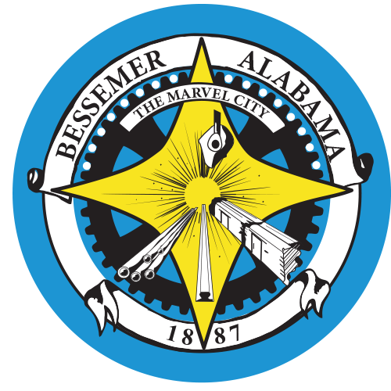
City of Bessemer
List of Candidates for Municipal Election (Mayor, City Council, School Board) to be held on August 23, 2022
Mayor
Kenneth “Ken” Gulley – Incumbent
1927 Granville Avenue
Bessemer, Alabama

Louise Alexander
2508 11th Avenue
Bessemer, Alabama

Wallace Anger
3026 7th Avenue North
Bessemer, Alabama

LaTricia Crusoe
2115 Dartmouth Avenue
Bessemer, Alabama

City Council
District 1
Jarvis Collier – Incumbent
709 4th Avenue North
Bessemer, Alabama

Michael Knight
1050 Barclay Drive
Bessemer, Alabama

District 2
Kimberly Alexander – Incumbent
2508 11th Avenue North
Bessemer, Alabama

Chester W. Porter
2401 12th Avenue North
Bessemer, Alabama

District 3

Cynthia Stephenson-Donald – Incumbent
2501 Fairfax Avenue
Bessemer, Alabama

Sarah Bell Person
3027 Arlington Avenue
Bessemer, Alabama

District 4

Donna Thigpen – Incumbent
6033 Pleasant Hill Road
Bessemer, Alabama

District 5

Ron Marshall – Incumbent
644 Elm Street SW
Bessemer, Alabama

Geortez Jackson
732 Castlewood Drive
Bessemer, Alabama

District 6

Carla Foreman Jackson
165 Royal Coach Circle
Bessemer, Alabama

Angela Hawkins Murray
1312 22nd Avenue
Bessemer, Alabama

District 7

Jay Howton
1501 Berkley Avenue
Bessemer, Alabama

Cleo King
505 Gladys Street
Bessemer, Alabama

Donald Wilson
804 Owen Avenue
Bessemer, Alabama

Bessemer City School Board

District 1

LaTesia Rancher
719 6th Avenue North
Bessemer, Alabama

Anthony Williams
1427 8th Avenue North
Bessemer, Alabama

Regina Cooper
1005 Barclay Drive
Bessemer, Alabama

District 2

Jimeneze Jennings
2906 10th Avenue North
Bessemer, Alabama

Terry Dawson
2401 12th Avenue North
Bessemer, Alabama

District 3

Renna Soles Scott – Incumbent
2666 Granville Avenue
Bessemer, Alabama

District 4

Sam Morris – Incumbent
1045 Overhill Road
Bessemer, Alabama

District 5

Jerome A. Cook – Incumbent
649 Elm Street SW
Bessemer, Alabama

Margie C. Varner
201 2nd Avenue East
Bessemer, Alabama

District 6

Remeka Thompson – Incumbent
516 Flint Hill Road
Bessemer, Alabama

District 7

Lee Jones – Incumbent
1516 Arlington Avenue
Bessemer, Alabama

